ITIS 4250 / 5250

Shivani Sathe

Research Project: Lab Option

30th November 2021

**Overview:**

On November 30, 2021, Detective Conan Benjamin handed me a case file along with two logical images. One image CollinWilliams.E01 was made from the suspect Collin William’s laptop, and the other CollinsUSB.E01 from a thumb drive found at the crime scene.  Detective Conan Benjamin had determined that in order to further the investigation forensic analysis needs to include any substantial information that can show Collin Williams was involved in the bombing attacks, was living under a secret identity and operated a high profile human trafficking racket.

For reference, a series of bombings had took place in town last week and recently there was a shootout at a residential complex where 2 people out of the 3 residing inside were killed. The 3rd one who survived was Collin Williams. Detective Conan Benjamin was determined that the two incidents were connected. Upon initial background check none of the 3 residents were found to be involved in any suspicious activity but Detective Benjamin found something fishy about Collin Williams behavior in the days following his release. Upon tacking and keeping a close watch on Collin, it was found that he is living with a secret identity in town and is infact a high profile member of a terrorist organization who is on a run for past 5 years leaving no clue behind for the police to use against him.

**Forensic Acquisition & Exam Preparation**

To begin the analysis, Windows 10, 64-bit system was used. The two forensic image files Colllin_Williams_System1.E01 and Collins_Thumbdrive.E01 were placed in a newly created folder named ‘**Graduate Lab**’ on desktop. The software used for the analysis were Access Data FTK Imager 4.5.0.3, Autopsy, WinPrefetchView, RegRipper, Keepass and Image Stegonagraphy. AccessData FTK Imager 4.5.0.3 was used to verify the MD5 hash value of both the images before starting the analysis. Following it, all the questions provided by Detective Conan Benjamin were answered. After the completion of analysis, the MD5 hash value of both the images were once again verified to ensure nothing has been altered. Below are the screenshots of MD5 hash value verification before starting the analysis and after the completion of analysis.

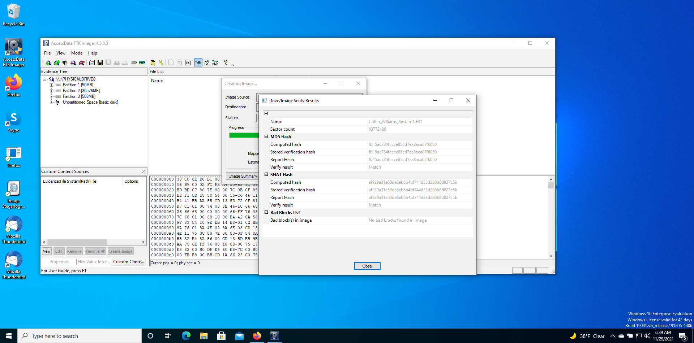

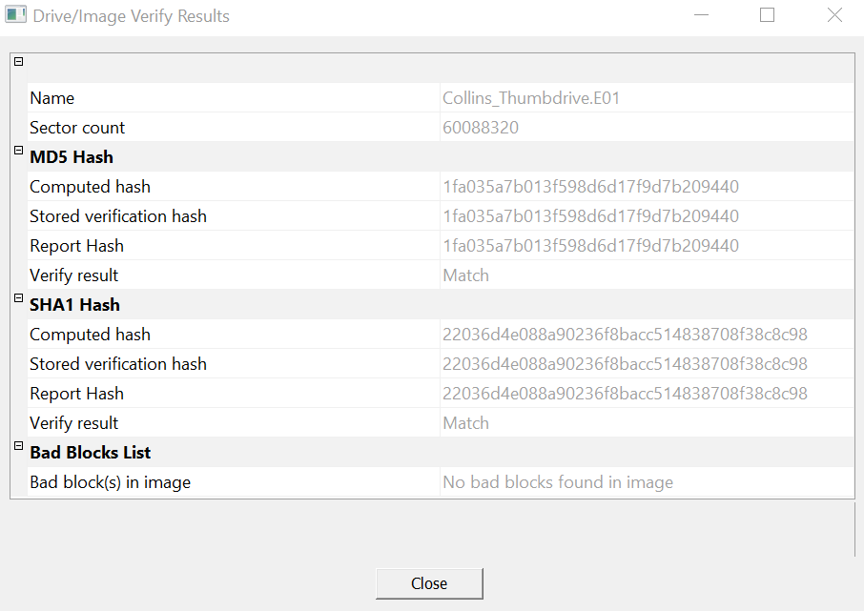

*Verification of hashes before analysis*





*Verification of hashes after analysis*

Autopsy was used and a new case was created by following below steps to load both forensic image file Colllin_Williams_System1.E01 and Collins_Thumbdrive.E01:

* Add Data Source
* Select Disk Image
* Browse Disk Image path
* Select required ingest modules
* Click on Finish

**Findings and Report (Forensic Analysis)**

1. **Account for how all the space on the computer hard drive of both images was used (partitions, used/free).**

Ans. Using FTK Imager, it was found that the image file Collin_Williams_System1.E01 has a total of three partitions and an unpartitioned space. Partition 1 has a starting sector of 2,048 and a sector count of 102,400. Overall, its size is 50MB. Partition 2 has a starting sector of 104,448 and a sector count of 62,619,758. Overall, its size is 30576MB. Partition 3 has a starting sector of 62,726,144 and a sector count of 1,040,384. Overall, its size is 508MB. The unpartitioned space has no size or partition information. Collin_Williams_System1.E01 image file has 512 bytes per sector and a sector count of 63,772,480. The total hard drive size upon calculation was found to be 32,651,509,760 i.e approx. 32651.50MB.

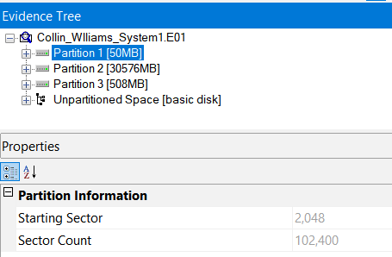 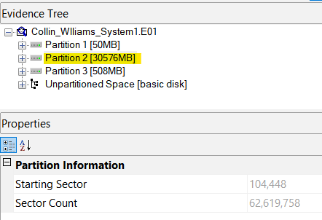

*Partition 1 overall size & partition Partition 2 overall size & partition*

*information information*

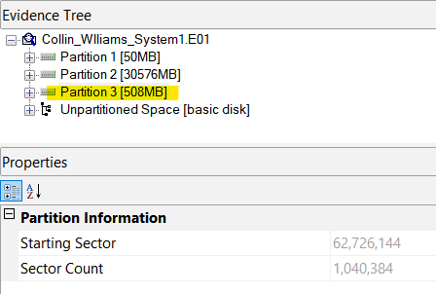 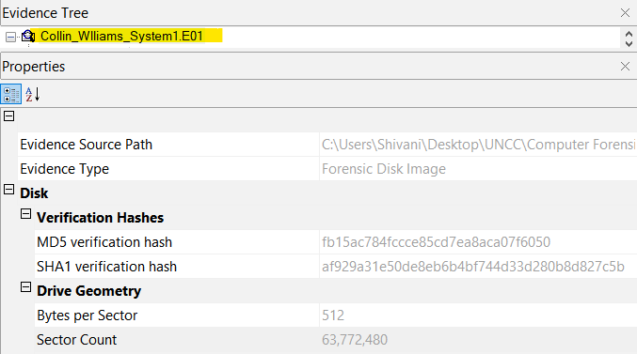

*Partition 3 overall size & partition Image file overall size*

*information*

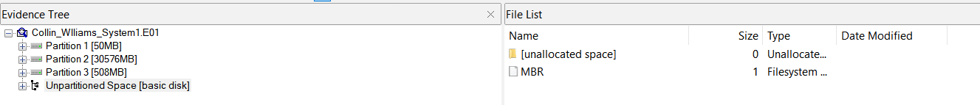

*Unpartioned Space*

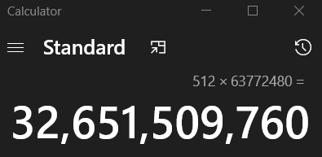

*Calculation of hardrive size*

For the image file Collins_Thumbdrive.E01, using FTK imager it was found that it has only 1 partition which has a starting sector of 32 and a sector count of 60,088,288 and an unpartitioned space.

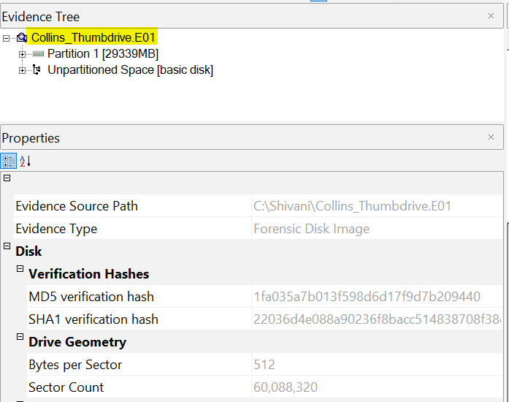 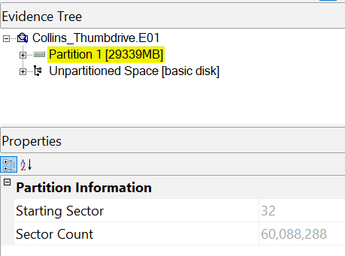

*Image file overall size Partition 1 overall size & partition*

*information*

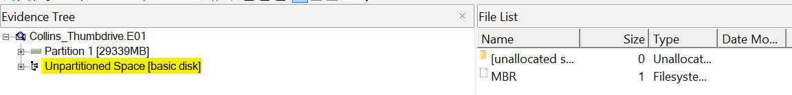

*Unpartioned Space*

1. **Identify the type of file systems in use.**

Ans: The file system present in all three partitions of image file ‘Collin_Williams_System1.E01’ is NTFS.

To find the file system, the forensic image ‘Collin_Williams_System1.E01’ was loaded in FTK imager. The image file was expanded using ‘+’ icon to browse through the volume levels and it was found that the file had 3 Partition. Upon expanding all the partitions, it was observed the image file has only 1 files system present which is NTFS.

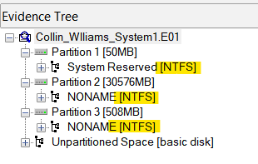

The file system present in image file ‘Collins_Thumbdrive.E01’ is FAT32.

To find the file system, the forensic image ‘Collins_Thumbdrive.E01’ was loaded in FTK imager. The image file was expanded using ‘+’ icon to browse through the volume levels and it was found that the file had 1 partition. Upon expanding the partition, it was observed the image file has only 1 files system present which is NTFS.

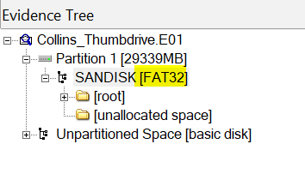

1. **Identify the version and service pack of the Operating System.**

Ans: Using Autopsy. at the path Data Artifacts -> Operating System Information, the version is found to be Windows NT. Below is the screenshot of the details.

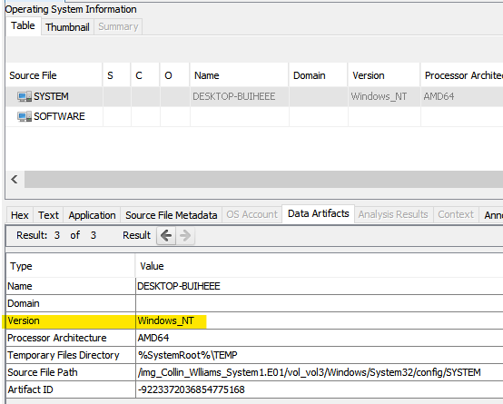

For more specific version, the current version is 6.3 which was found in Software hive at path Data sources\ Collin_Williams_System1.E01\vol3 \Windows\System32\config\SOFTWARE:/ Microsoft\Windows NT\CurrentVersion.

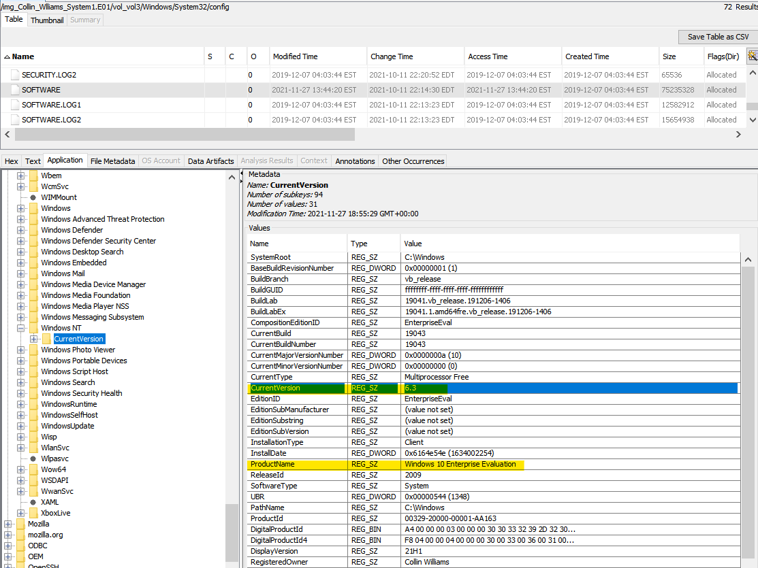

Windows 10 Operating System does not have a service pack.Please refer to below screenshot.

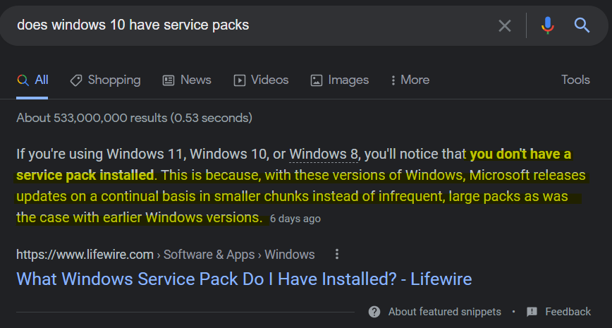

1. **Identify the Time Zone information for the computer.**

Ans: The Time Zone of the computer is Pacific Standard Time. This was found using Autopsy, in System hive under TimeZoneKeyName field at path Data sources\ Collin_Williams_System1.E01\vol3 \Windows\System32\config\SYSTEM:/ControlSet001\TimeZoneInformation

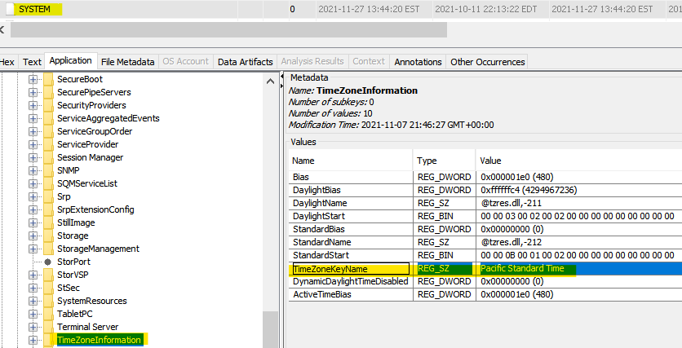

1. **Show the owner of the computer.**

**Ans:** The owner of the computer is Collin Williams. This information was found using Autopsy under Software Hive in RegisteredOwner field at path Data sources\ Collin_Williams_System1.E01\vol3\Windows\System32\config\SOFTWARE:/ Microsoft\Windows NT\CurrentVersion.

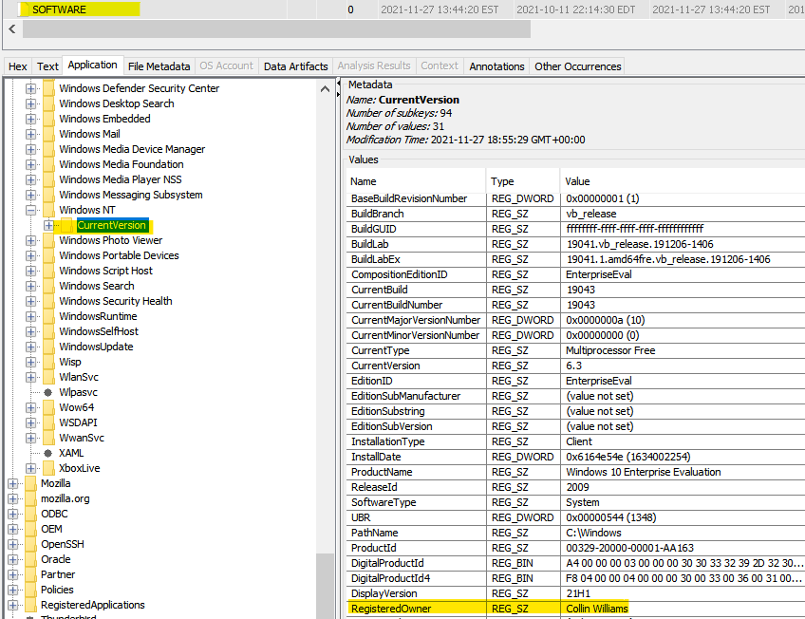

1. **Identify the number of user accounts created.**

Ans: There were a total of 2 user accounts created. The username of one account was Collin Williams and the username of second account was anwrb. This information was found using autopsy at path Analysis Results -> OS accounts.

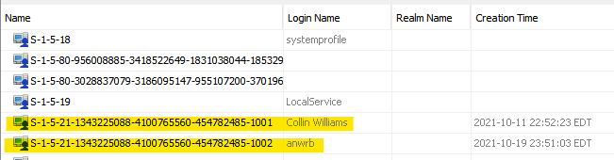

1. **Identify the last user who logged in and when.**

Ans. The last used username was **anwrb** . Using autopsy, this information was found at location Data sources\Collin_Williams_System1.E01\vol3\Windows\System32\ config\SOFTWARE:/ Microsoft\Windows NT\CurrentVersion\winlogon

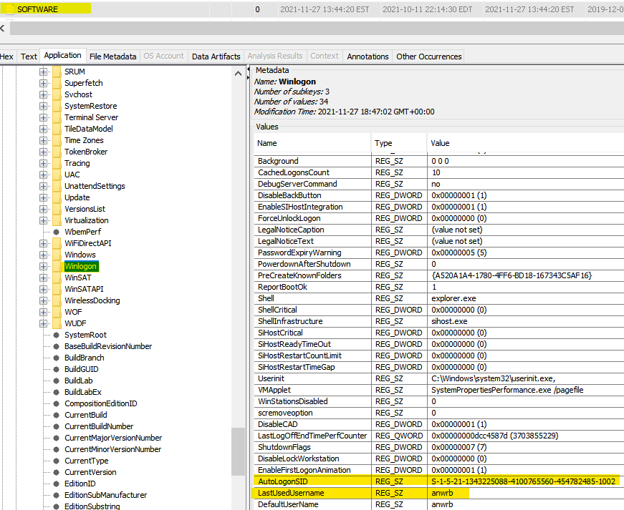

The last login time is 2021-11-27 05:39:06Z .To find the time of last login**,** from Autopsy, the SAM file was extracted from path Data sources\Collin_Williams_System1.E01\ vol3\Windows\System32\Config\SAM. Using RegRipper tool, this SAM file was ripped to observe its contents.

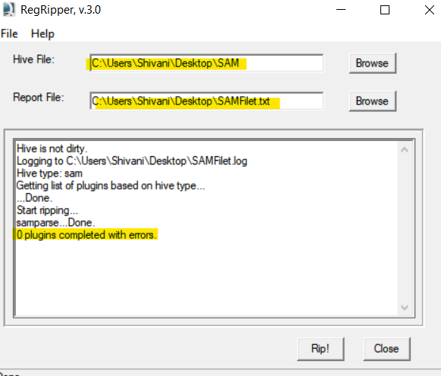 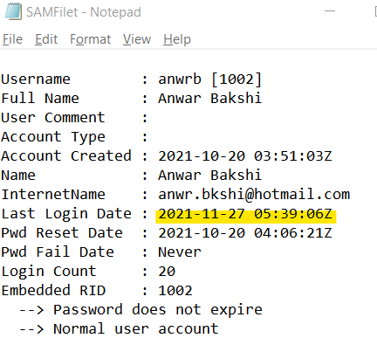

1. **Identify any users current account picture.**

Ans: Using Autopsy, both the users account’s current account picture were found by navigating to the directory Data sources\Collin_Williams_System1.E01\ vol3/Users/Public/AccountPictures

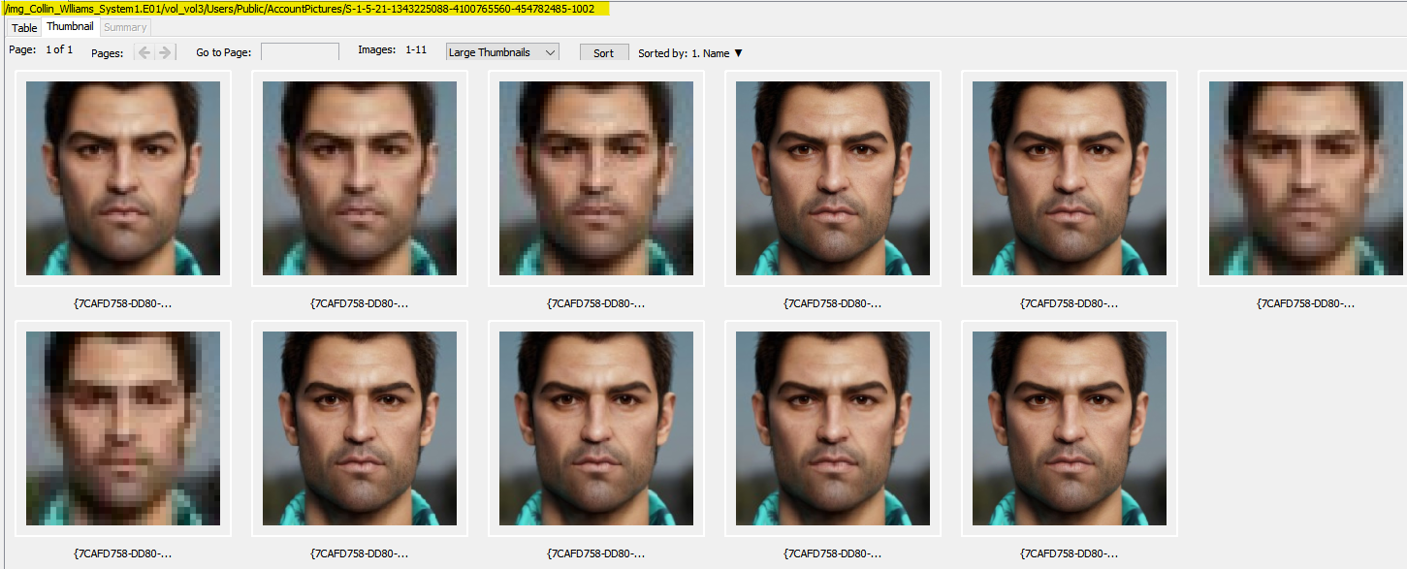

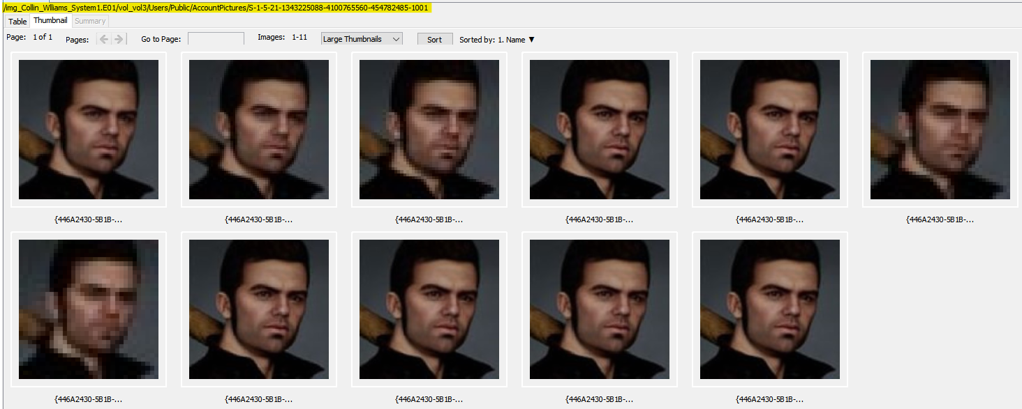

1. **Identify the recent documents the subject accessed and when were they accessed?**

Ans: The recent documents accessed were as in below screenshot. They were found using Autopsy at path Data Atrifacts -> Recent Documents. It was observed that all the recently opened documents were accessed using user account **anwrb**.

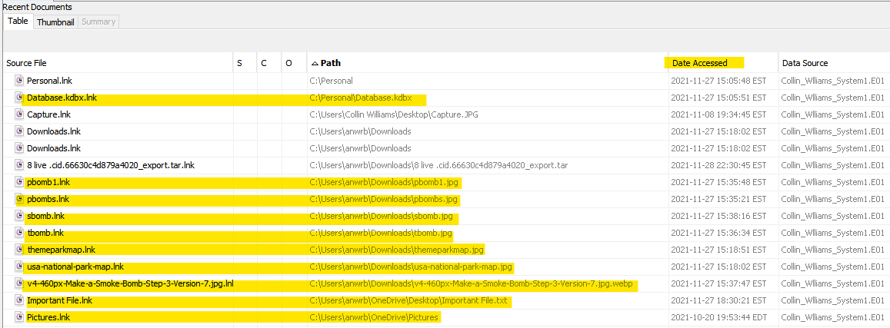

1. **List any application whose presence is found to be unusual in the system.**

Ans: 2 software applications were found whose presence was found to be unusual, namely KeePass and Image Steganography. Using Autopsy, the prefetch file was extracted from Data sources/Collin_Williams_System1.E01/ vol3/Windows/Prefetch. Using WinPrefetchView tool, from the advanced options, the prefetch file of Collin_Williams_System1.E01 was opened.

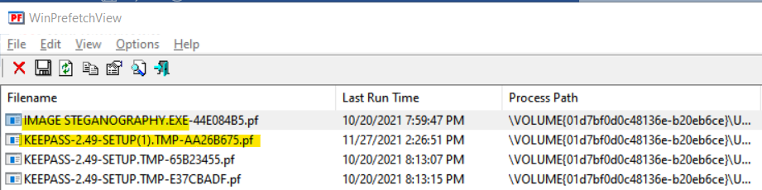

1. **Was the suspect living under any secret identity?**

Ans: Yes, the suspect Collin Williams was living under a secret identity. The real identity of the suspect is Anwar Bakshi who was currently living in the name of Collin Williams. This information was found from the files located at Data Artifacts - > Recycle bin. It consisted of 2 passport pictures and a plastic surgery document. Below is the screenshot of the evidences.

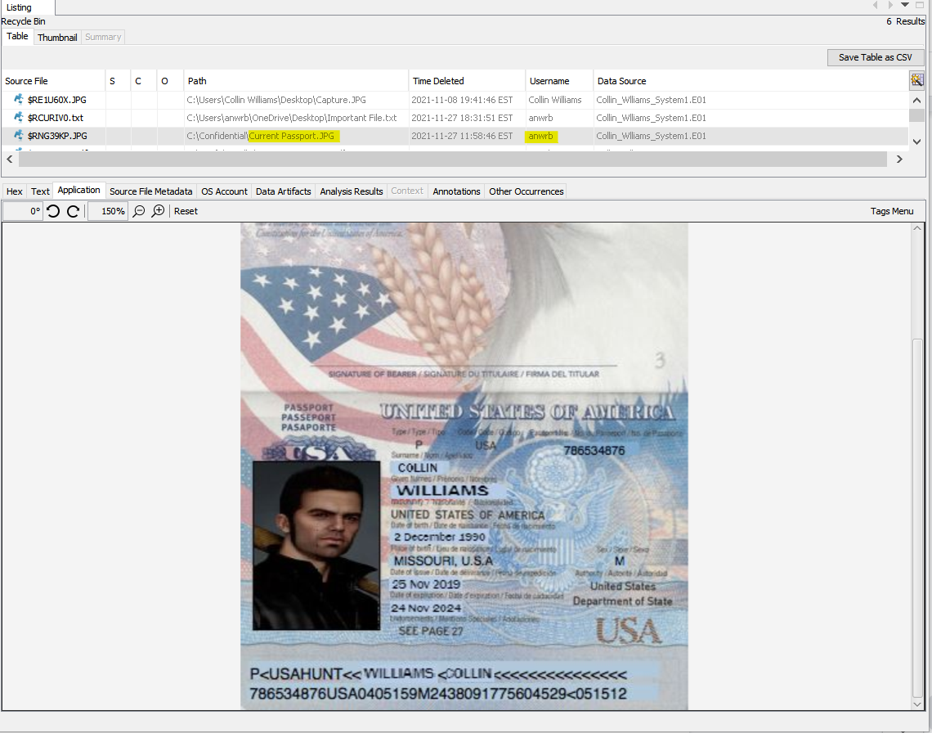

*Supposedly fake passport copy with name Collin Williams*

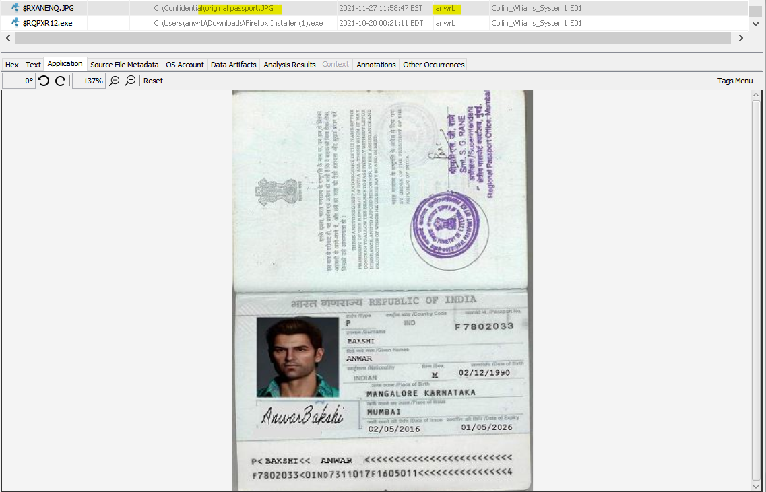

*Passport Copy in the name of Anwar Bakshi*

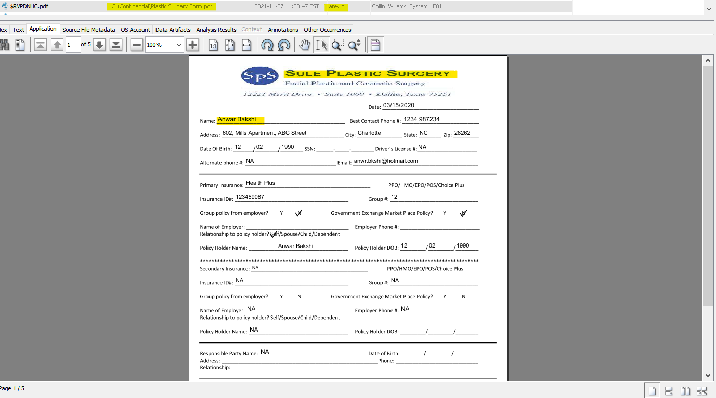

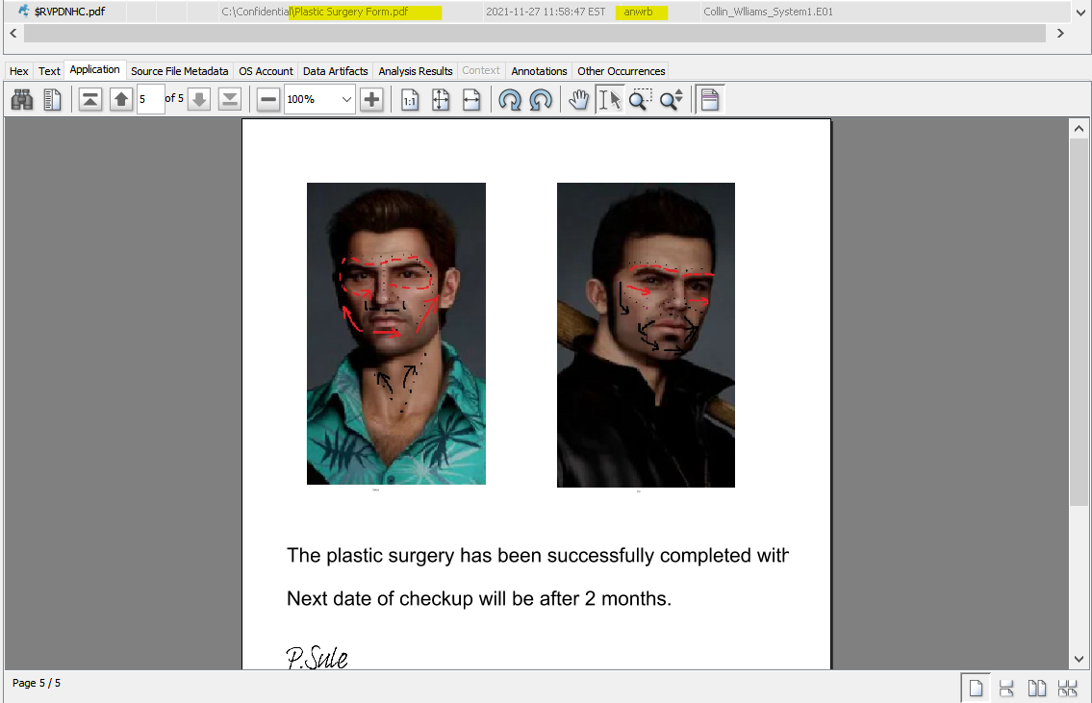

*Plastic surgery document*

1. **Are there any items that show the suspect would be involved in making bombs?**

Ans: Yes, items were found that shows the suspect’s high chances of being involved in making bombs. Using Autopsy, below Web search results were found which could be related to his involment. The items were at the following path; Data Artifacts 🡪 Web Search

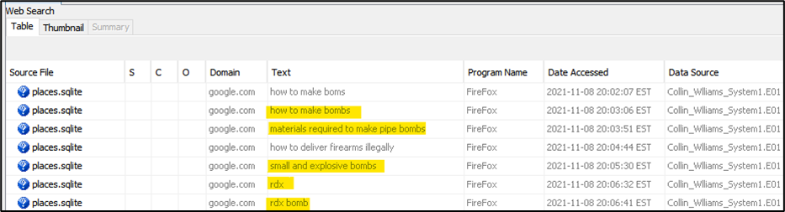

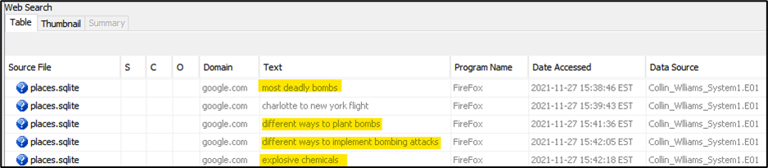

There is an email from email address [anwr.bkshi@hotmail.com](mailto:anwr.bkshi@hotmail.com) found at path Data Artifacts 🡪 Email Messages 🡪 Default 🡪 Default which states that ‘bombs are in making’. This email address could be the actual email address of Anwar Bakshi alias Collin Williams.

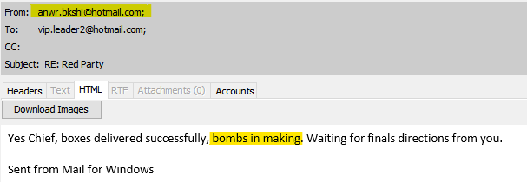

Below images were found at location-

/img_Collin_Wlliams_System1.E01/vol_vol3/Users/anwrb/Downloads/

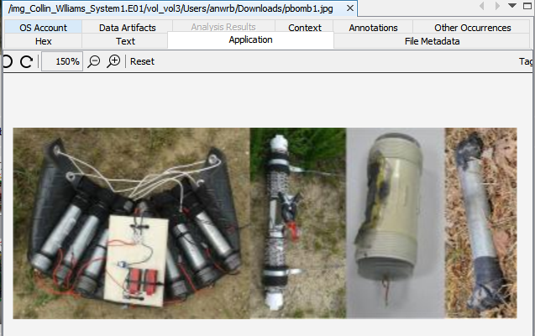 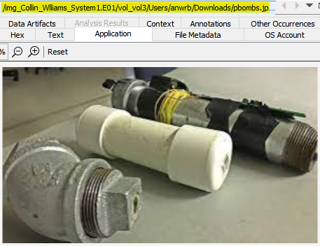

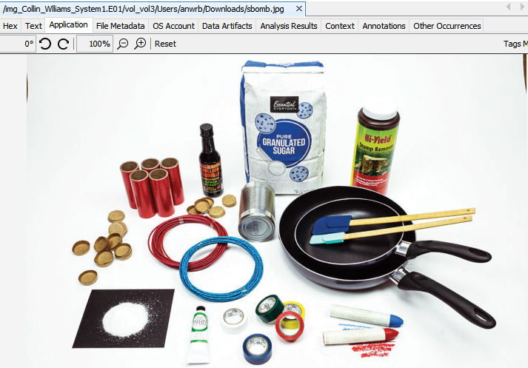 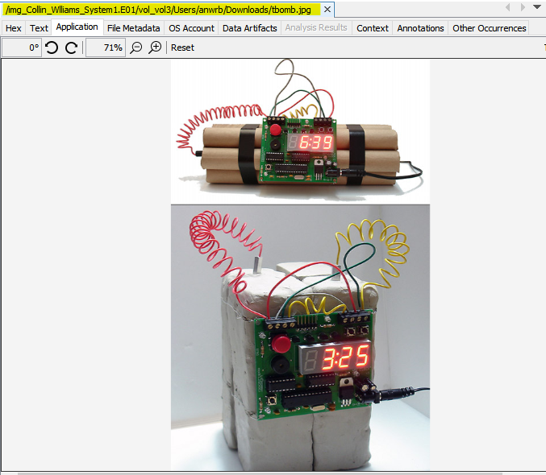

1. **Is the suspect the mastermind of the bombing attack?**

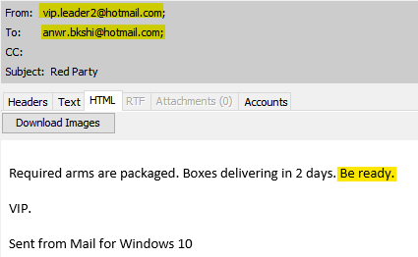Ans. No, the suspect is not the mastermind. There are email communications observed where the suspect was being directed on implementing plans from a specific email address i.e **vip.leader2@hotmail.com** These mail communications were found at location Data Artifacts 🡪 Email Messages 🡪 Default 🡪 Default. Below are the screenshots of the details.

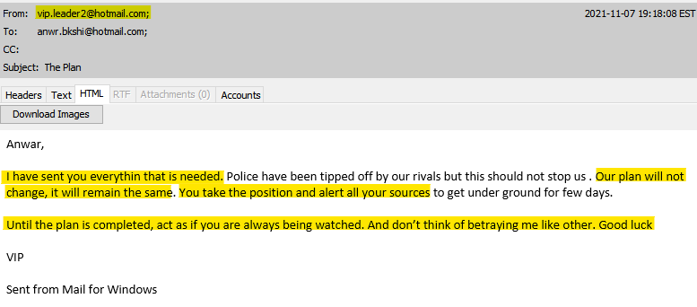

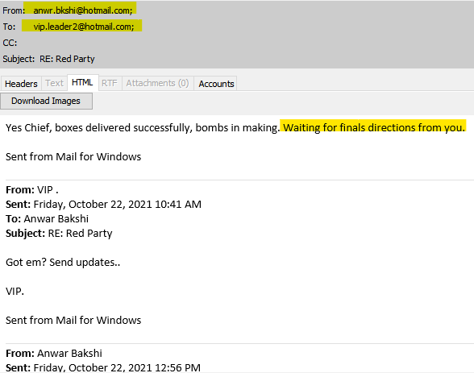 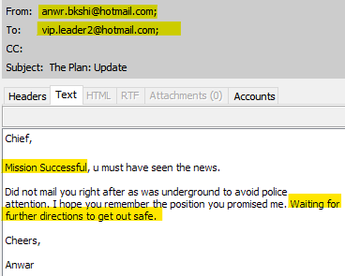

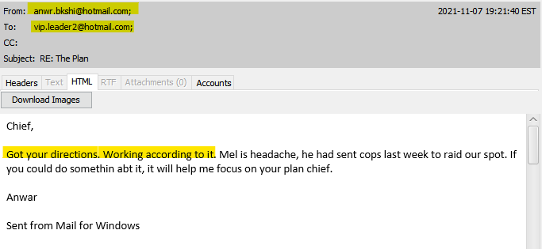

1. **Are there any passwords that can be recovered?**

Ans: Yes, a file was found at path Data Artifacts -> Recycle Bin which consisted of a master password of a database. The password is RedParty@2021!

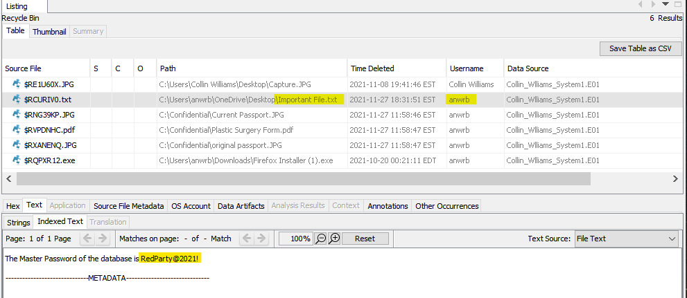

Also, a password database file was recovered from location /img_Collin_Wlliams_System1.E01/vol_vol3/Personal/Database.kdbx. The files having extension ‘**.kdbx**’ are created by KeePass Password Safe application which is a password manager for Windows OS.

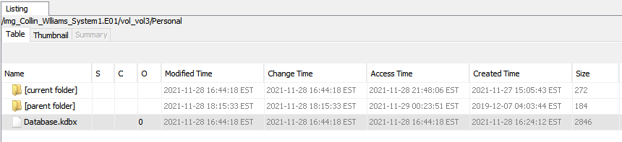

This database file was extracted from autopsy and was loaded into the Keepass application to recover more passwords. This database file required a master password to proceed further. Using the password found in the file ImportantFile.txt as above, the database was accessed.

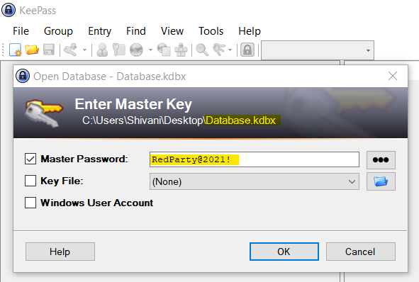

The database consisted of many other passwords as in below screenshots

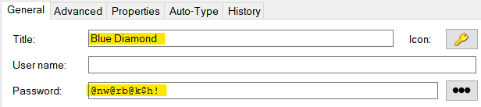 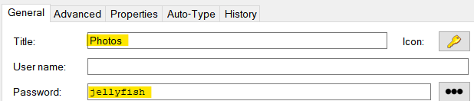

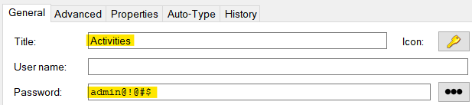

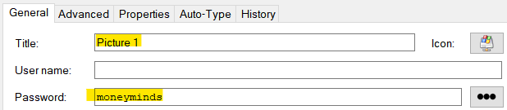

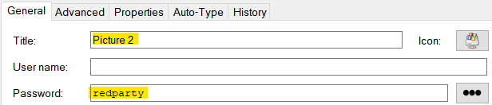

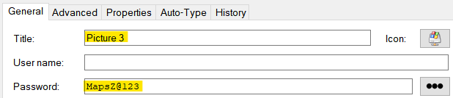

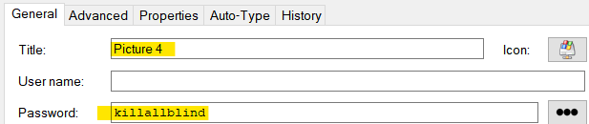

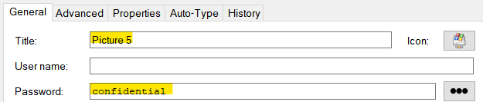

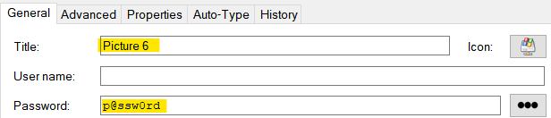

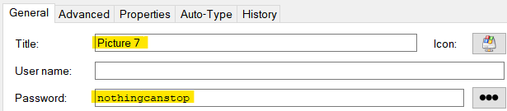

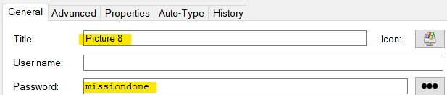

1. **Identify any items that show precise information regarding the location and timings of the bombings that had taken place.**

Ans: A series of email communication threads were found from email address [vip.leader2@hotmail.com](mailto:vip.leader2@hotmail.com) which contained pictures as attachment. These pictures directly relate to the exact location of the bombing attack. Using Autopsy, the emails were found at location Data Artifacts 🡪 Email Messages 🡪 Default 🡪 Default.

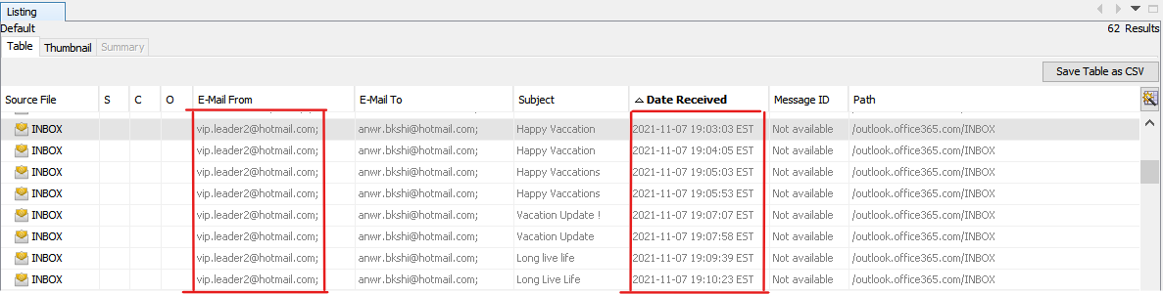

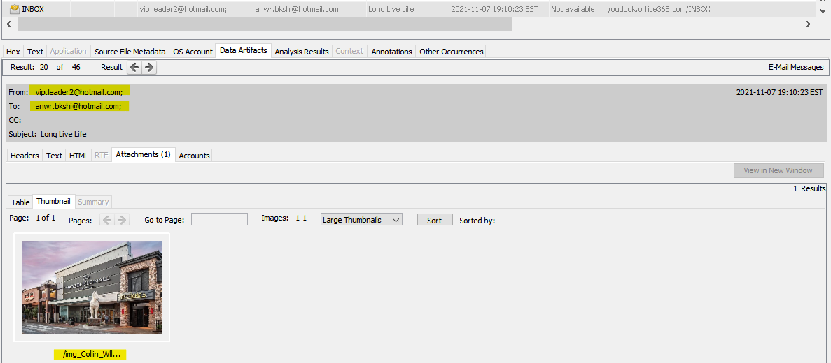

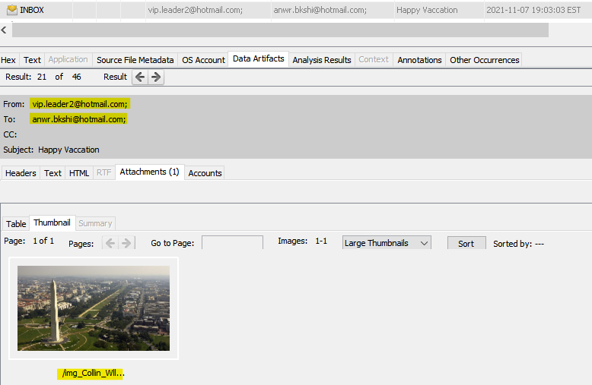

Below are all the pictures found as attachment in the email threads. This was located at /img_Collin_Wlliams_System1.E01/vol_vol3/Users/anwrb/AppData/Roaming/Thunderbird/Profiles/aifzm5tu.default-release/ImapMail/outlook.office365.com/INBOX.

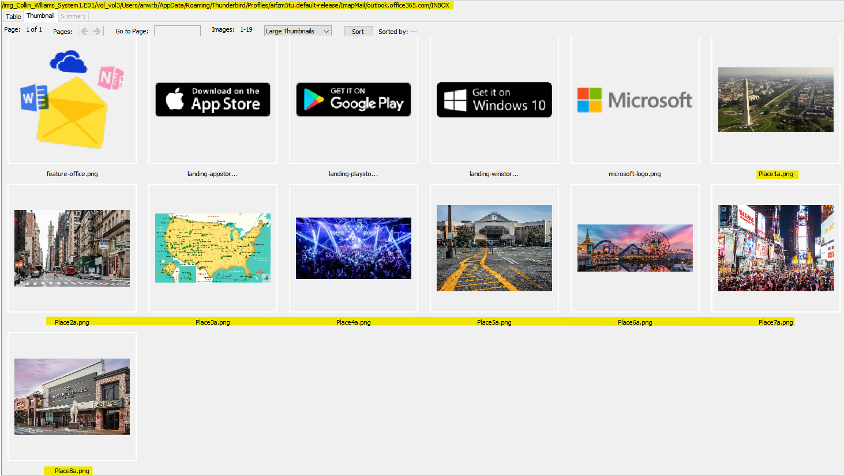

The timings of the bombings were hidden inside these images in a text files using Image Steganography tool. These images were extracted from Autopsy and loaded in Image Steganography Tool. Upon loading, every image was found to be encrypted with a password.

Using the passwords recovered from the Keepass database file for the entries titiled Picture1-Picture 8 , every picture was decrypted and a text file was found hidden inside the image. Below are the screenshots for more details-

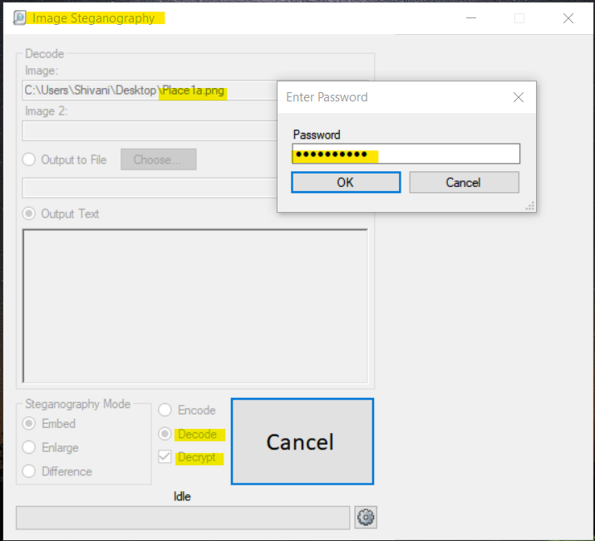

*Decrypting the picture titled ‘Place1a’, using password ‘moneyminds’ as found in the Keepass database for entry ‘Picture1’*

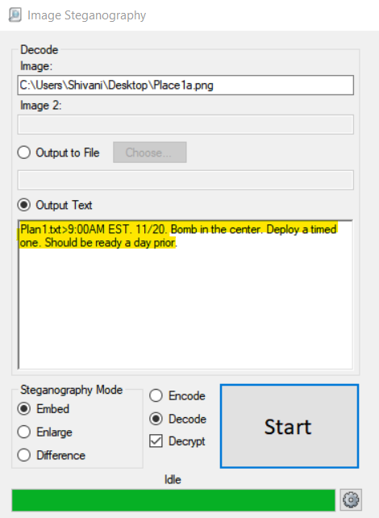

*Result of decrypting the picture titled ‘Place1a’. The time matches exactly with the actual bombing attack*

Similarly decrypting all the 8 pictures from the email attachments using the passwords found in Keepass database, below is the screenshot of every textfile hidden in the picture.

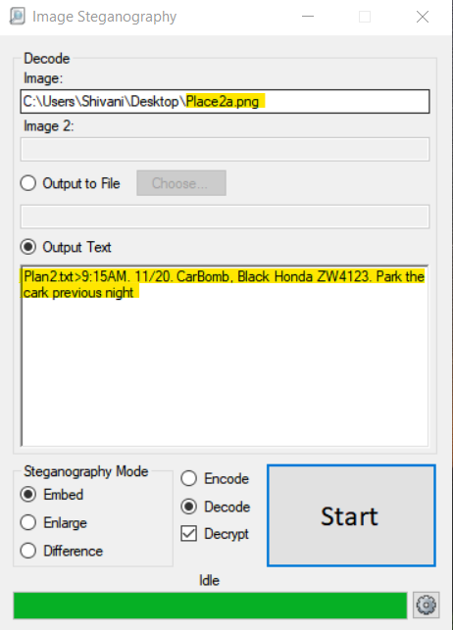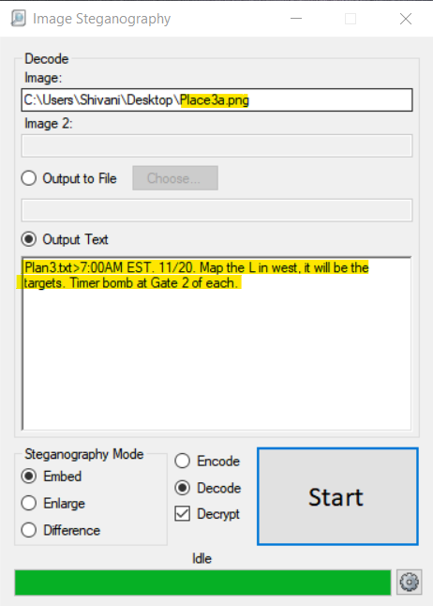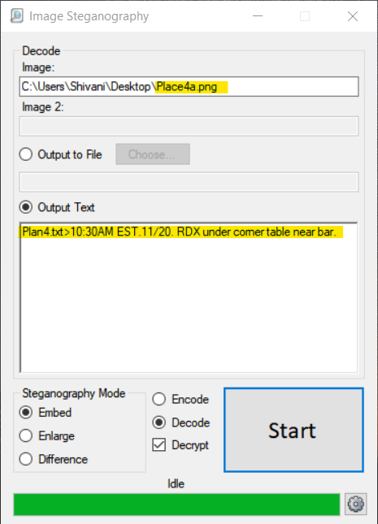

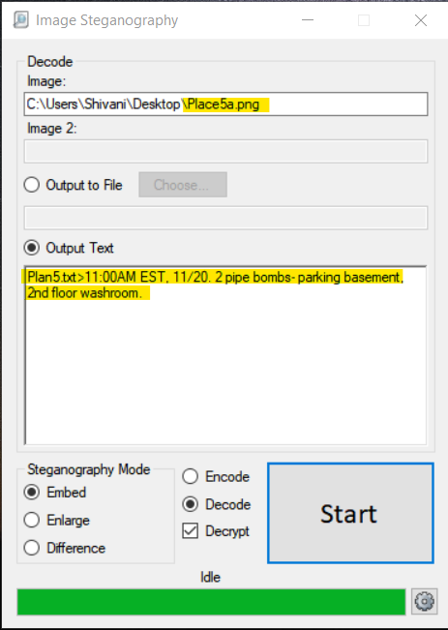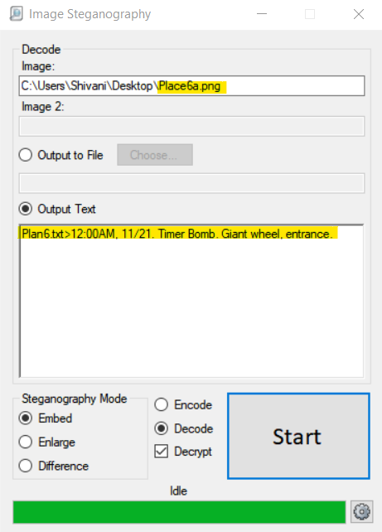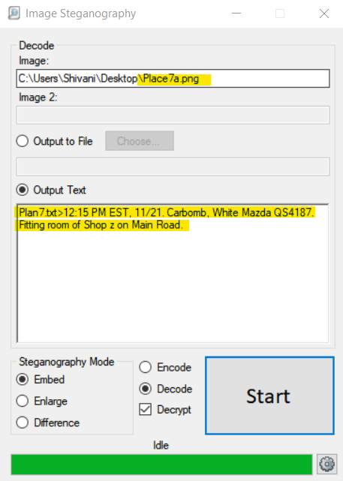

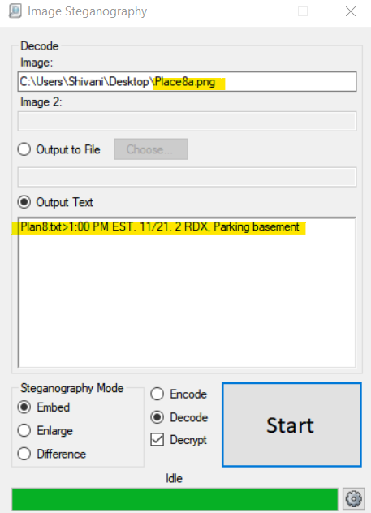

1. **Are there any other illegal activities that the suspect is involved in?**

Ans: Yes, the suspect is operating a human trafficking racket and is responsible for murders details of which were found in the email communications and the carved files from the image file Collins_Thumbdrive.E01. Using autopsy, the carved files were found at location /img_Collins_Thumbdrive.E01/vol_vol2//$CarvedFiles/.

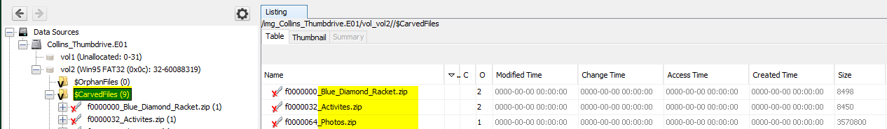

There were 3 files in total and all were encrypted using password. The names of these files matched with the entries of the KeePass password database. All the 3 files were extracted from autopsy and accessed using the password from the KeePass database. Below is the screenshot of the files.

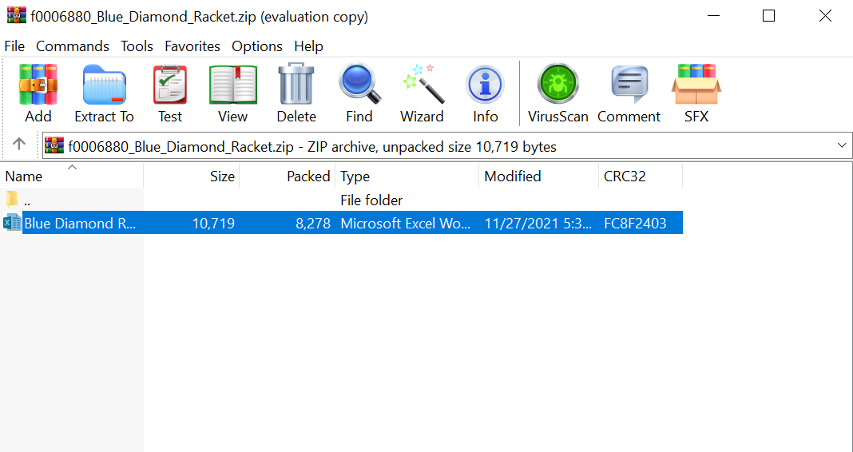

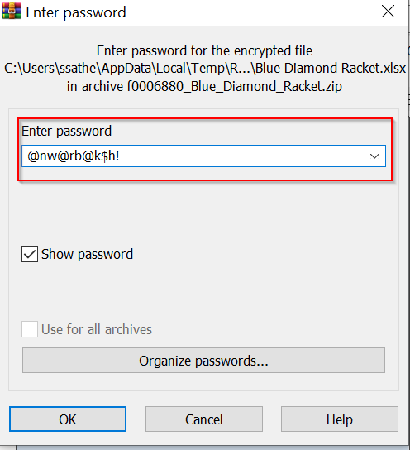

*Entering the password found in the database for file BlueDiamondRacket.xlsx*

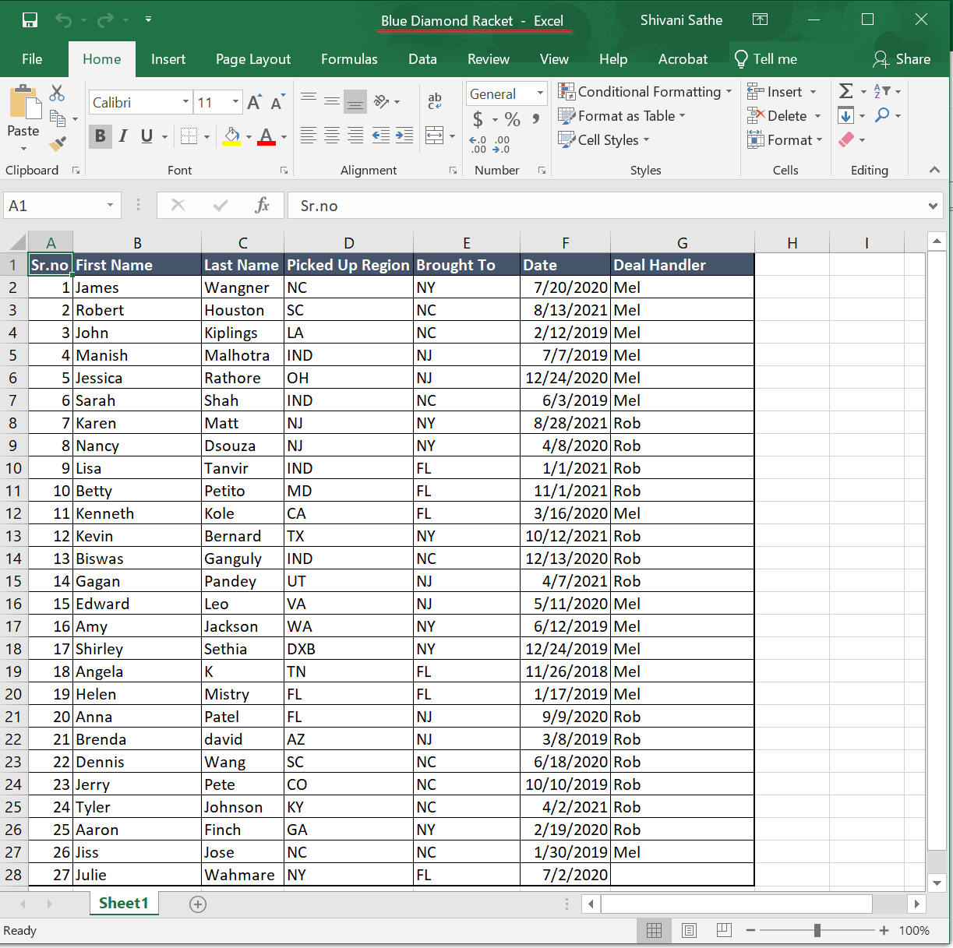

*File consisting details of the trafficked people.*

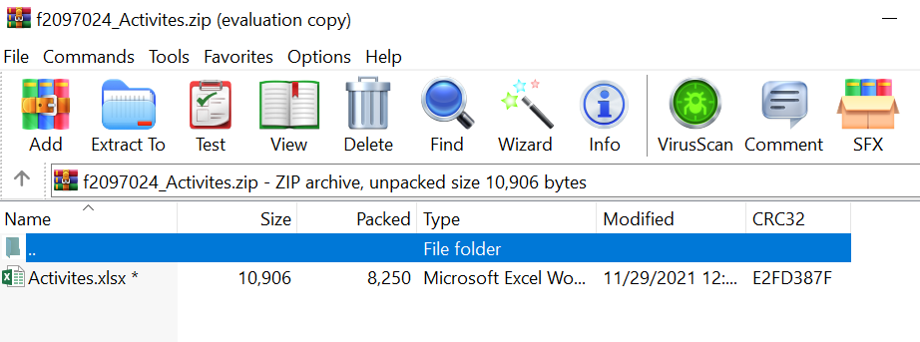

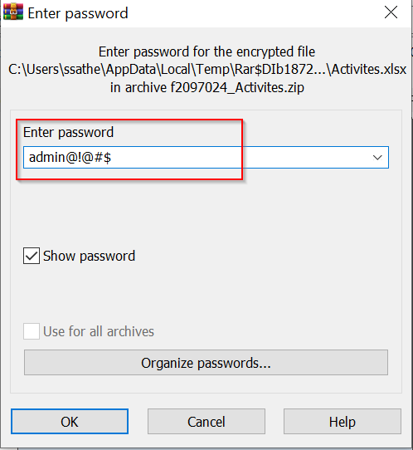

*Entering the password found in the database for file Activities.xlsx*

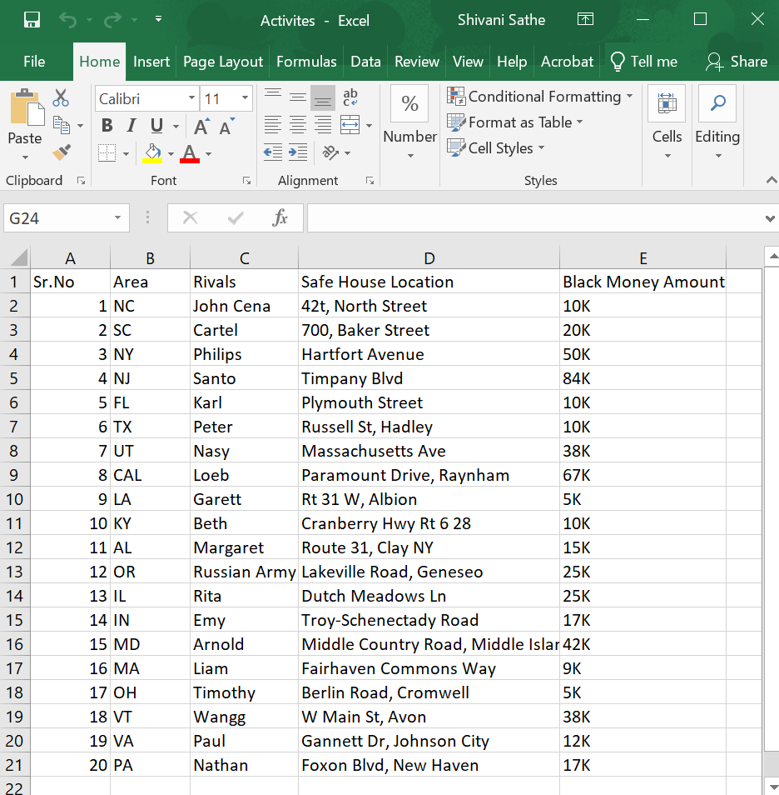

*Details of black money and safe house locations.*

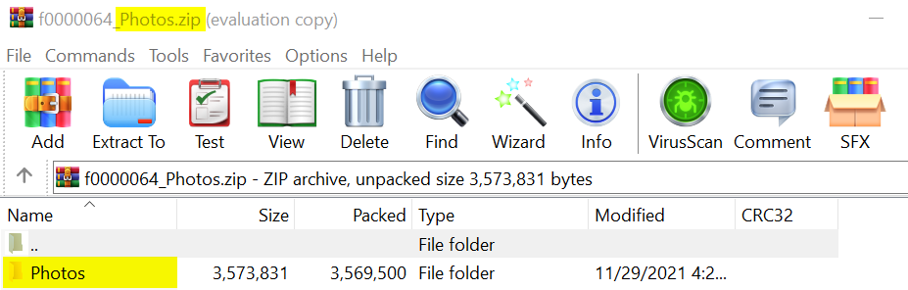

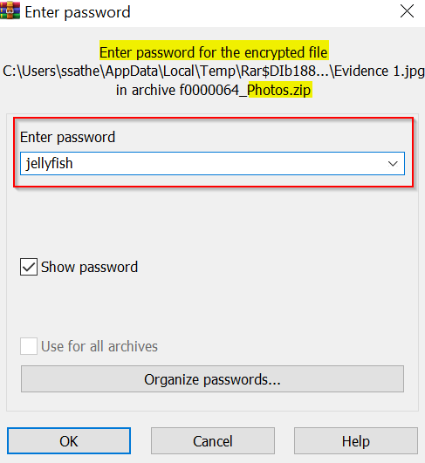

*Entering the password found in the database for folder Photos*

Below are the pictures found in the ‘Photos’ folder where the suspect is seen exchanging suitcases which could be of a human trafficking deal. Also, there are pictures of the suspect shooting 2 people.

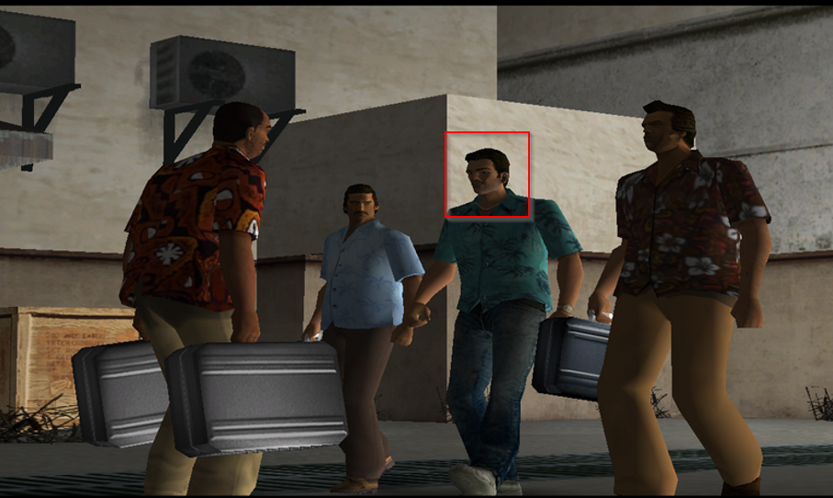

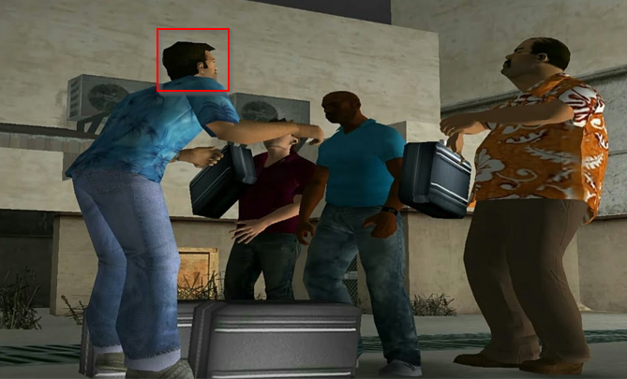

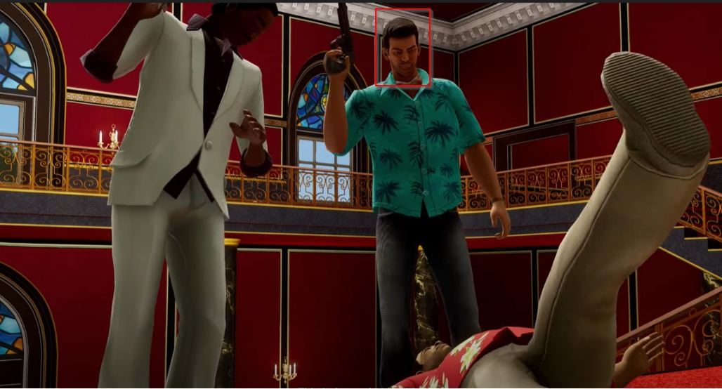

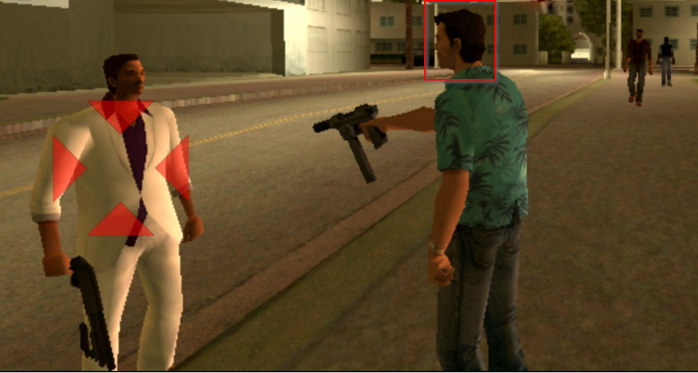

Apart from the above files, email communication were found where the suspect is making deals regarding human trafficking. This was found using Autopsy from the image file Colllin_Williams_System1.E01 at location Data Artifacts 🡪 Email Messages 🡪 Default 🡪 Default. Below are the screenshots of the details-

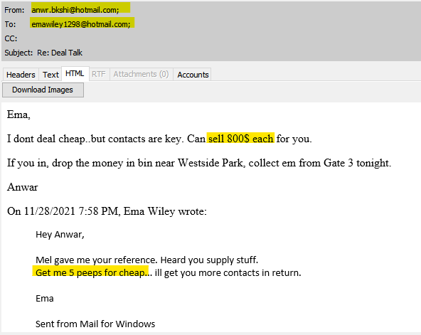

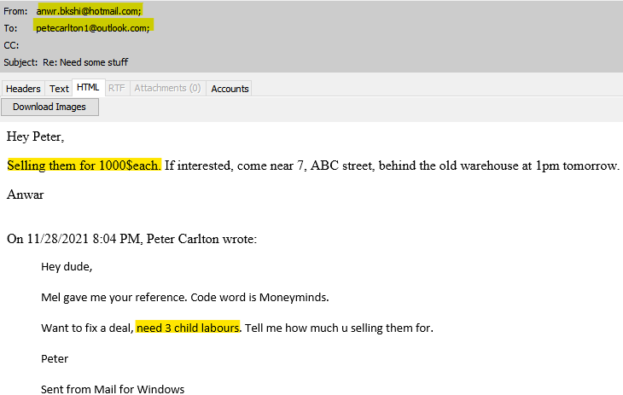

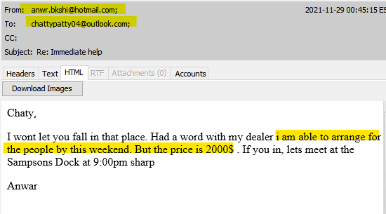

1. **What are the email addresses of the other members of Collin’s gang?**

Ans: The email address are: robbieroaster000@gmail.com, mel_noir@outlook.com and joshpinel@hotmail.com. These were found from the email threads from the image file image file Colllin_Williams_System1.E01 at location Data Artifacts 🡪 Email Messages 🡪 Default 🡪 Default. Below are the screenshots of the details-

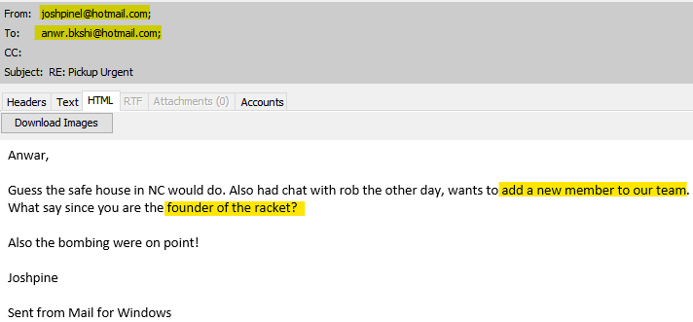

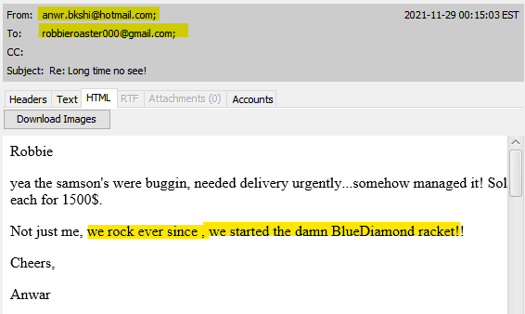

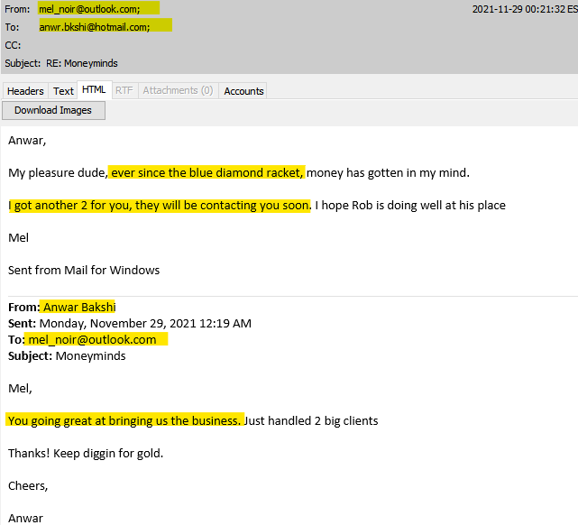

1. **Do the evidences show that the suspect is living under a secret identity, carried out the bombing attacks and is involved in other illegal activity?**

Ans: Based on the evidences, it appears that suspect is a living under secret identity who carried out the bombing attacks and is involved in other illegal activity. From the plastic surgery document and the passport copies, it can be concluded that the real identity of the suspect is Anwar Bakshi who has been living under the secret identity of Collin Williams.

The web searches and pictures found in the email attachments which had the place, time and location of bombings proves that the suspect had carried out the terrorist activity.

Also, from the carved files found from the thumb drive image and the email communications, it is observed that the suspect is operating a human trafficking racket name Blue Diamond and is also responsible in murdering two people.

**Conclusion**

Overall, the analysis performed was to prove that the suspect Collin Williams was living under a secret identity, carried out the bombing attacks and is engaged in other illegal activities. To begin the analysis, the image was loaded using AccessData FTK Imager 4.5.0.3 on a Windows 10 Machine and the hash value of image was verified to conclude that it was not tampered before the analysis process. With the help of Autopsy, the 2 provided images were examined and all the questions regarding this case were successfully answered. The image was again verified using AccessData FTK Imager to ensure it was not altered. No evidence has been retained. The forensic image, and answered questions regarding it, were returned to Detective Conan Benjamin.

Signed:

Shivani Sathe

Digital Forensics Examiner